Unified Ensemble Learning for Cyber Attack Detection and Classification in Wireless Sensor Networks
A. P. Chitralingappa
A. Department of CSE (Data Science), Srinivasa Ramanujan Institute of Technology, Anantapur, India., p.chitralingappa@gmail.com;
B. B. Lakshmi Moksha, C. Dinesh Reddy, P. Karthik and R. Akash
Department of CSE (Data Science), Srinivasa Ramanujan Institute of Technology, Anantapur, India. lakshmimoksha.132@gmail.com, dineshreddy3450@gmail.com, penukondakarthik5@gmail.com, akashramugalla@gmail.com

ABSTRACT: Wireless Sensor Networks (WSNs) have several applications, including environmental monitoring, healthcare, and industrial automation; however, their wireless communication media and limited computing capabilities make them very susceptible to cyberattacks. Current systems are typically focused on detecting attacks rather than properly classifying various types of attacks that occur within dynamic networks. The present study proposes a unified stacking ensemble-based cyberattack detection and classification framework that incorporates a variety of machine learning and deep learning models, including Random Forest (RF), Extreme Gradient Boosting (XGBoost), Multilayer Perceptron (MLP), and Autoencoder. The WSN-DS benchmark dataset will be utilized for training the various models, while the COOJA simulator will generate realistic WSN traffic used for evaluation of the ensemble framework. The proposed ensemble framework utilizes supervised learning to classify known attacks and utilize unsupervised anomaly detection to identify unknown attacks. The experimental results show that the proposed unified ensemble framework has a 99.88% detection accuracy, and outperforms each of the individual models in terms of classification stability and reliability of detection. Furthermore, the proposed unified ensemble framework supports real-time monitoring of cyberattacks, forensic logging, and recommendations for preventing future attacks; therefore, the proposed ensemble framework can potentially be deployed in actual Wireless Sensor Network (WSNs) environments.

INTRODUCTION
The application of Wireless Sensor Networks is common in industrial automation, environmental monitoring, as well as in healthcare. Combined with the Internet of Things (IoT), they enable a steady collection of data and assist in informative and timely real-time decision making [20][27]. Attacks are a threat to WSNs due to their open wireless medium and limited hardware resources. As an illustration, attackers can use weak processing power and battery life [1][6][12].
A cyberattack refers to the illegal attempt to gain access to, degrade, computer networks, or computer-related data. Blackhole, Grayhole, Flooding and TDMA-based attacks are some of the cyberattacks that have become a significant security threat, as WSNs are deployed swiftly. A Blackhole attack is an attack where a malicious node will claim to have the best path to the base station and proceeds to discard every packet it gets [21][25]. Grayhole attack is more misleading since it is only the selected packets that are dropped and this makes it more challenging to detect. Flooding attacks introduce too many packets into the network hence jamming it and consuming a lot of energy of sensor nodes in no time. During TDMA-based attacks, an attacker sends his data at unauthorized time slots thereby causing collisions and interfering with regular communication. These attacks sabotage routing processes, more packets are lost, and more power is used in sensor nodes [8][10].
Most security systems available today are primarily geared towards the detection of attacks and they usually do not effectively categorize various types of attacks or are not modified to match the changing threat of a dynamic network environment [2]. Also, benchmark data sets like WSN-DS have assisted researchers to examine WSN communication behavior and attack
To deal with these issues, smart and responsive cybersecurity technologies are necessary. Machine learning and deep learning in combination with ensemble learning models can enhance the detection accuracy and stability of classification and the robustness of the system. Therefore, the suggested system uses various ensemble learning models as a single ensemble model to enhance the detection and classification of cyberattacks [24]. patterns in a better manner [16].

Related work

Wireless Sensor Networks (WSNs) have a high susceptibility to cyberattacks since they are spread out, use wireless communication media and lack the necessary resources in terms of computation and power. The use of cryptographic protection is often inadequate for WSN environments as attackers can compromise the sensor nodes, introduce malicious packets, or perform denial-of-service attacks to disrupt network services [11]. Besides, it is not easy to employ elaborate security systems on every sensor node due to hardware and battery capacity constraints, and therefore, effective and compact cyberattack detection methods are critical in WSN security [7][13][26].
In order to mitigate these threats, machine learning-based and anomaly detection methods have been extensively investigated [4]. Network traffic patterns are analyzed using models such as XGBoost, Random Forest, and ensemble based algorithms to detect abnormal behavior and known attack signatures. These models often provide excellent detection and classification performance.[3][5][9][15]. Deep learning methods have also enhanced cyberattack detection by learning complex and nonlinear relationships in network traffic data [23]. Multilayer Perceptron and Autoencoder models have shown good results in detecting cyberattacks and classifying network behavior. [14][18][22].
Specialized datasets have also helped in developing intelligent cyber security models. The WSN-DS dataset was actually developed to model the real-world WSN communication behavior and different denial-of-service attack scenarios. [17].
Numerous current methods cannot detect the changing patterns of attacks and they are also incapable of categorizing the precise type of attack and they are also expensive to train the deep learning models [19]. Moreover, the available systems are mostly based on single- model learning methods and do not have adaptive multi-model systems that can be used in the context of real-time WSN. These restrictions demonstrate the necessity of intelligent security frameworks that are hybridized ensemble-based.

3 Proposed Methodology

3.1 System Overview
The design of our proposed system is shown in Figure 1. The system contains three main modules: the user interaction module (UI), cyberattack detection engine, and data storage module. The user interface module is used to provide interaction between the user and the system where several features such as the uploading of the dataset, registration of the user, authentication, and access to forensic logs, prevention reports and detection outputs may be provided.
The cyberattack detection engine is the key processing component of the system. It will do the preprocessing of the data, run ensemble learning models, detect possible cyberattacks, categorize the type of attack and recommendations on what measures should be taken to prevent the attack. The engine flexibly analyzes the network behavior to identify suspicious patterns of network behavior.
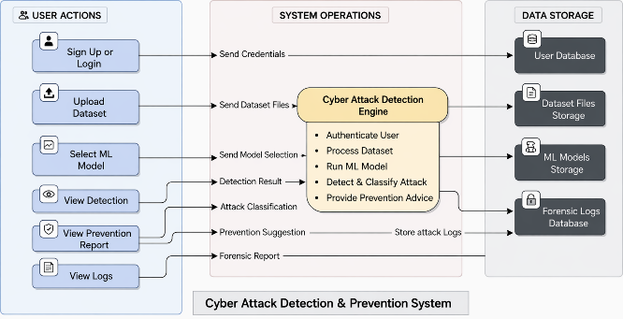

Figure. 1 Proposed Cyber Attack Detection and Prevention Design Architecture

3.2 Need for a Unified Ensemble Learning Model
Instead of encrypting all frames, a selection function determines which frames are processed to reduce computational overhead. In traditional WSN intrusion detection systems, a single machine learning model is typically used for detection; therefore, the ability to detect more complex and evolving types of cyberattacks is limited. Different models will have unique capabilities, such as: Random Forest - well-suited for noisy data; XG Boost - captures complex decision boundaries; neural networks - can detect patterns in nonlinear types of network traffic. Consequently, this paper proposes a stacking ensemble approach enhance detection accuracy, classification stability against continuously changing attack patterns.

3.3 Dataset Processing Workflow
The workflow starts with data training by utilizing the WSN DS benchmark dataset to collect information and network traffic information through the COOJA simulation environment, which would be used to test and validate the experiment and make sure that realistic scenarios regarding the communication.
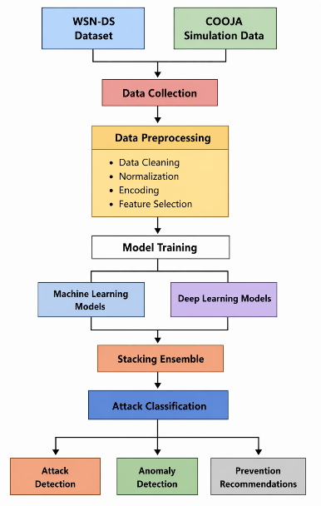

Figure. 2 Overview of Data Processing Workflow
Data cleaning, data normalization, categorical encoding, and feature selection are carried out to perform preprocessing of the collected data to improve data quality and model training. Then unified ensemble model is trained using processed dataset. It is used to perform multi-attack classification, to detect seen or unseen cyberattacks. The system also writes prevention recommendations based on the outcome of the detection to aid proactive cybersecurity monitoring in Wireless Sensor Network networks.

3.4 Ensemble Learning
The proposed system makes use of the unified ensemble learning model to improve the dependability of cyberattack classification and the accuracy of cyberattack detection in WSNs. This system integrates hybrid learning models to learn different patterns of network traffic behavior and cyberattack patterns.
One of the base models is Random Forest because of the high classification ability and resistance to the noisy and high-dimensional data.
The XG Boost is also present in the framework to enhance the accuracy of prediction by means of boosting based learning. It is suitable in dealing with non-linear boundaries.
Multilayer Perceptron (MLP) model is utilized to extract the nonlinear relations among network traffic data. The patterns of WSN communication are in most cases nonlinear and conceal dependencies among the network parameters.
The Autoencoder model is applied in detecting anomalies and identifying the previously unseen cyberattack patterns. This allows the system to identify the unknown attacks which are not available in the training dataset.

4 Experimental Setup
The purpose of the experiment is to evaluate how well the suggested unified ensemble-based cyberattack detection system for WSNs. The available dataset is partitioned so that most samples (80%) are used for model training, while (20%) is used to test model performance.

4.1 Training Dataset
The dataset used to train the proposed model is the WSN-DS dataset consisting of 374,661 samples of network communication of normal traffic and cyberattacks. Some of these attack types are Blackhole attacks, Grayhole attacks, Flooding and TDMA attacks which are included in the dataset.

4.2 Simulation Environment
To verify the functionality of the unified ensemble model under realistic conditions of the Wireless Sensor Network, more network traffic is simulated with the help of COOJA network simulator tool, which is a part of the Contiki-NG operating system. The scenario of simulation reflects real-life practice regarding deployment of the Wireless Sensor Network and the communication process. The sensor nodes are randomly scattered in an area of the simulation and a base station is located in the middle of the simulation area to gather the sensed data of all sensor nodes. Sensor nodes send data to the base station in periodic unidirectional communication with the use of multi-hop routing in which the sensor nodes transmit packets to intermediate nodes to achieve reliable data transmission. The network communication is based on IEEE 802.15.4 wireless communication.
The COOJA simulation settings used to generate validation dataset are shown in Table 1.

Settings | Values Used in Simulation
Node Type | COOJA sensor mote
Number of Nodes | 200 nodes
Node Distribution | Random deployment in 200m x 200m area
Simulation Time | 900 seconds
Radio Medium | UDGM (Unit Disk Graph Medium)
Transmission Range | 50 meters
MAC Protocol | IEEE 802.15.4
Communication Protocol | UDP
Packet Transmission Interval | 5 seconds
Energy Consumption Monitoring | Enabled (per-node energy tracking)
Network Traffic Logs | Mote output logs converted to CSV format

Table 1: COOJA Simulation Settings

5 Results and Analysis
The proposed unified ensemble model with a total accuracy of 99.88% has a high capacity of detecting and classifying cyberattacks in WSNs.
Model | Classification Rate | Positive Predictive Value | Detection Rate | Harmonic Score
Unified Ensemble | 99.88 | 0.99 | 0.99 | 0.99
XGBoost | 99.73 | 0.95 | 0.99 | 0.97
Random Forest | 99.71 | 0.93 | 0.99 | 0.96
Multilayer Perceptron | 90.76 | 0.18 | 0.20 | 0.19
Autoencoder | 99.12 | 0.98 | 0.99 | 0.98
Table 2: Comparative Analysis of Base Models and the Proposed Unified Method
Table 2 states that, results of the comparison suggest that the unified ensemble model is more effective in comparison with base models in achieving better detection and stability of classification.
Figure 3 shows real-time cyberattack output. The system identifies attack type, severity level, provides mitigation recommendations. This proves the real time detection and prevention of the system.

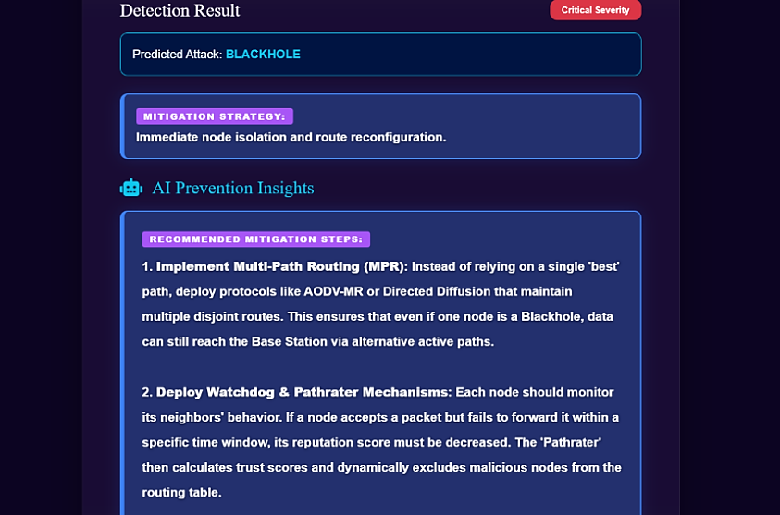

Figure 3: : Attack Detection and Prevention
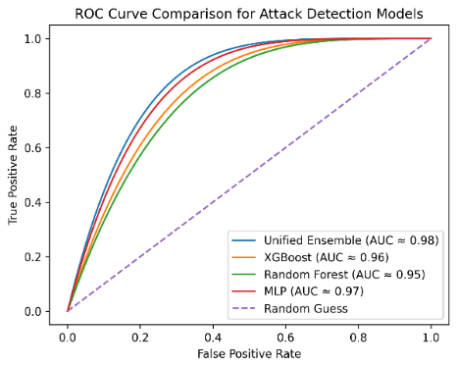

Figure 4: ROC Curve Comparison of Cyberattack Detection Models
As shown in Figure 4, the proposed unified ensemble model achieves the highest AUC value of 0.980, outperforming the individual machine learning models.

5.1 Evaluation Metrics
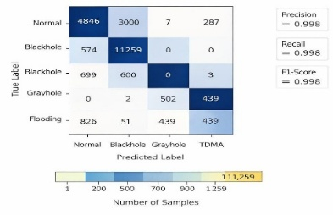
The effectiveness of the proposed unified ensemble model is measured through conventional metrics of determining its capability to identify cyberattacks and classify them on Wireless Sensor Networks.

Figure 5: Confusion Matrix of the Proposed Unified Ensemble Model.

Figure 5 shows the performance of the unified ensemble model on the classification of the various type of attacks. The diagonal of the matrix implies that the model is successful at classifying most network traffic samples.

6 Conclusion and Future Work
In this paper, Unified Stacking Ensemble is proposed as a Cyber-Attack Detection framework for Wireless Sensor Networks. For improved detection and classification of types of attacks, a combination of Random Forests, XGBoost, Multi-Layer Perceptron (MLP) and Autoencoder models have been developed. The models were trained WSN-DS and tested with traffic captured in the COOJA simulator. Experimental results have shown that the Unified Stacking Ensemble Model has achieved an overall detection accuracy of 99.88% and classifies attacks with more reliable classifications than the individual machine learning models. The proposed model supports forensic logging of attack activity, and recommendations to mitigate future attack attempts.
Future studies will be aimed at enhancing the given system by integrating modern deep learning frameworks such as Graph Neural Networks to increase the precision of cyberattacks detection in a massive scale Wireless Sensor Networks.

7 References
Dr. B. Karthikeyan, MS. M. Kamali , " Detection of Attacks in Wireless Sensor Networks Using Machine Learning Algorithms " , International Journal of Research Publication and Reviews, Vol 6, no 2, pp 3454-3460 February 2025

Al-Quayed, Z. Ahmad, and M. Humayun, "A Situation Based Predictive Approach for Cybersecurity Intrusion Detection and Prevention Using Machine Learning and Deep Learning Algorithms in Wireless Sensor Networks of Industry 4.0," IEEE Access, vol. 12, pp. 34800-34816, 2024, presented at the IEEE Access Conference, New York, USA, March 2024, doi: 10.1109/ACCESS.2024.3372187

M. Anwer, S. M. Khan, M. U. Farooq, and . Waseemullah, “Attack Detection in IoT using Machine Learning”, Eng. Technol. Appl. Sci. Res., vol. 11, no. 3, pp. 7273–7278, Jun. 2021

Delwar, Tahesin Samira, Unal Aras, Sayak Mukhopadhyay, Akshay Kumar, Ujwala Kshirsagar, Yangwon Lee, Mangal Singh, and Jee-Youl Ryu. 2024. "The Intersection of Machine Learning and Wireless Sensor Network Security for Cyber-Attack Detection: A Detailed Analysis" Sensors 24, no. 19: 6377. https://doi.org/10.3390/s24196377

Tamara Zhukabayeva, Atdhe Buja, Melinda Pacolli, Yerik Mardenov, "Detecting network security incidents in wireless sensor networks using machine learning ," Detecting network security incidents in wireless sensor networks using machine learning Indonesian Journal of Electrical Engineering and Computer Science,Vol. 37, No. 3, March 2025, DOI: http://doi.org/10.11591/ijeecs.v37.i3.pp1650-1660

Behiry, M.H., Aly, M. Cyberattack detection in wireless sensor networks using a hybrid feature reduction technique with AI and machine learning methods. J Big Data 11, 16 (2024). https://doi.org/10.1186/s40537-023-00870-w.

G. Al Sukkar and S. Al-Sharaeh, “Enhancing Security in Wireless Sensor Networks: A Machine Learning-based DoS Attack Detection”, Eng. Technol. Appl. Sci. Res., vol. 15, no. 1, pp. 19712–19719, Feb. 2025.

Khan, I., Junaid Khan, Bangash, S. H., Waqas Ahmad, Khan, A. I., & hameed , khalid. (2024). Intrusion Detection Using Machine Learning and Deep Learning Models on Cyber Security Attacks. VFAST Transactions on Software Engineering, 12(2), 95–113. https://doi.org/10.21015/vtse.v12i2.1817.

Sadia, H., “Intrusion Detection System for Wireless Sensor Networks: A Machine Learning Based Approach”, IEEE Access, vol. 12, IEEE, pp. 52565–52582, 2024. doi:10.1109/ACCESS.2024.3380014.

Buja, Atdhe & Zhukabayeva, Tamara & Pacolli, Melinda & Mardenov, Yerik. (2025). Detecting network security incidents in wireless sensor networks using machine learning. Indonesian Journal of Electrical Engineering and Computer Science. 37. 1650-1660. 10.11591/ijeecs.v37.i3.pp1650-1660.

Salmi, S., Oughdir, L. Performance evaluation of deep learning techniques for DoS attacks detection in wireless sensor network. J Big Data 10, 17 (2023).

N.Harini, D. Siva Naga Srivalli, A. Asritha, A.Govardhini, G.Pujitha, and B.Geetha Bhavani, “CyberSecurity Intrusion Detection in Industry 4.0 WSN’s Using ML/DL”, Int. J. Comput. Eng. Res. Trends, vol. 12, no. 2, pp. 18–28, Feb. 2025.

nalluri, suryaprakash, Efficient Intrusion Detection Model for Cyber-Attack Mitigation in Wireless Sensor Networks (December01, 2024).

Ismail WN. A Novel Metaheuristic-Based Methodology for Attack Detection in Wireless Communication Networks. Mathematics. 2025

M. A. Talukder, S. Sharmin, M. A. Uddin, M. M. Islam, and S. Aryal, “MLSTL-WSN: Machine learning-based intrusion detection using SMOTETomek in WSNs,” arXiv preprint arXiv:2402.13277, 2024. [Online].

Tabbaa, H., Ifzarne, S., and Hafidi, I., “An Online Ensemble Learning Model for Detecting Attacks in WirelessSensorNetworks”, doi:10.48550

Alamin Talukder, M., Sharmin, S., Ashraf Uddin, M., Manowarul Islam, M., and Aryal, S., “MLSTL-WSN: Machine Learning-based Intrusion Detection using SMOTETomek in WSNs”, doi:10.48550/arXiv.2402.13277.

Sinha, P., Sahu, D., Prakash, S. et al. An efficient data driven framework for intrusion detection in wireless sensor networks using deep learning. Sci Rep 15, 34046 (2025). https://doi.org/10.1038/s41598-025-12867-x

Shakya, Vandana & Choudhary, Jaytrilok & Singh, Dhirendra. (2025). Deep Learning based Intrusion Detection System for WSN. Procedia Computer Science. 258. 2101-2106. 10.1016/j.procs.2025.04.460.

Gueriani, Afrah & Kheddar, Hamza & MAZARI, Ahmed Cherif. (2024). Deep Reinforcement Learning for Intrusion Detection in IoT: A Survey. 10.48550/arXiv.2405.20038.

Gurajada, Lalitha & Rajaputra, Sai & Gogineni, Indira & Shaik, Riaz. (2018). Security Attacks in Wireless Sensor Networks. International Journal of Engineering and Technology(UAE). 7. 322-326. 10.14419/ijet.v7i2.32.15704.

Gebremariam, G. G., Panda, J., & Indu, S. (2023). Design of advanced intrusion detection systems based on hybrid machine learning techniques in hierarchically wireless sensor networks. Connection Science, 35(1). https://doi.org/10.1080/09540091.2023.2246703

Haque, Ahshanul & Chowdhury, Naseef & Soliman, Hamdy & Hossen, Mohammad Sahinur & Fatima, Tanjim & Ahmed, Imtiaz. (2023). Wireless Sensor Networks anomaly detection using Machine Learning: A Survey. 10.48550/arXiv.2303.08823.

Ismail, S.; El Mrabet, Z.; Reza, H. An Ensemble-Based Machine Learning Approach for Cyber-Attacks Detection in Wireless Sensor Networks. Appl. Sci. 2023, 13, 30. https://doi.org/10.3390/app13010030

A. N. Doss, D. Shah, G. F. Smaisim, M. Olha and S. Jaiswal, "A Comprehensive Analysis of Internet of Things (IOT) in Enhancing Data Security for Better System Integrity - A Critical Analysis on the Security Attacks and Relevant Countermeasures," 2022 2nd International Conference on Advance Computing and Innovative Technologies in Engineering (ICACITE), Greater Noida, India, 2022, pp. 165-167, doi: 10.1109/ICACITE53722.2022.9823817.

K. J. Gnanaselvi, S. K. Shukla, K. Kumar, A. Gehlot, T. Jaiswal and B. T. Geetha, "A Novel based Hybrid smart System for detecting the cyber-attacks on IOT’s," 2023 International Conference on Artificial Intelligence and Smart Communication (AISC), Greater Noida, India, 2023, pp. 600-604, doi: 10.1109/AISC56616.2023.10085521.

S. L. Bangare, S. Prakash, K. Gulati, B. Veeru, G. Dhiman and S. Jaiswal, "The Architecture, Classification, and Unsolved Research Issues of Big Data extraction as well as decomposing the Internet of Vehicles (IoV)," 2021 6th International Conference on Signal Processing, Computing and Control (ISPCC), Solan, India, 2021, pp. 566-571, doi: 10.1109/ISPCC53510.2021.9609451.

